Data mining Lab 01 – Data preprocessing

Contents

Student information 1

Self-evaluation 1

Requirement 1 – Weka installation 2

Requirement 2 – Begin with Weka 4

Requirement 2.1 – Reading data 4

Requirement 2.2 – Exploring weather dataset 8

Requirement 2.3 – Exploring German credit dataset 11

Requirement 3 – Preprocessing implementation 20

List missing 20

Imputing 22

Remove sample and attribute 24

Remove sample with threshold 24

Remove attribute with threshold 25

Remove duplicated samples 26

Normalizing 26

Add new attribute with given expression 28

References 30

# Student information

In this lab, we work in the group of two whose information is shown in the following table:

|  |  |  |  |
| --- | --- | --- | --- |
| Class | 19KHMT | | |
| No | **Student name** | **Student ID** | **Contribution** |
| 1 | Do Vuong Phuc | 19127242 | 50% |
| 2 | Bui Dang Khoa | 19127645 | 50% |

# Self-evaluation

We have done all the given task from installation to the implementation with detail document.

# Requirement 1 – Weka installation

1. **Screenshot of Weka with desktop**

Do Vuong Phuc’s screenshot:

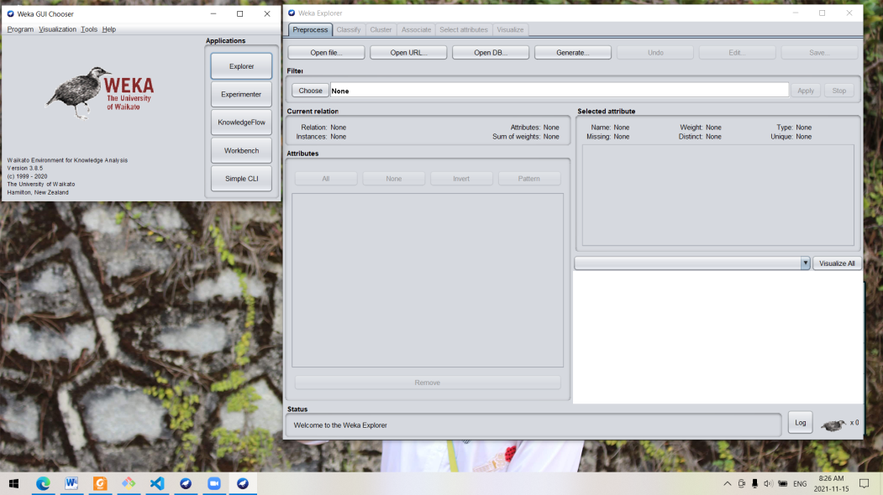

Bui Dang Khoa’s screenshot:

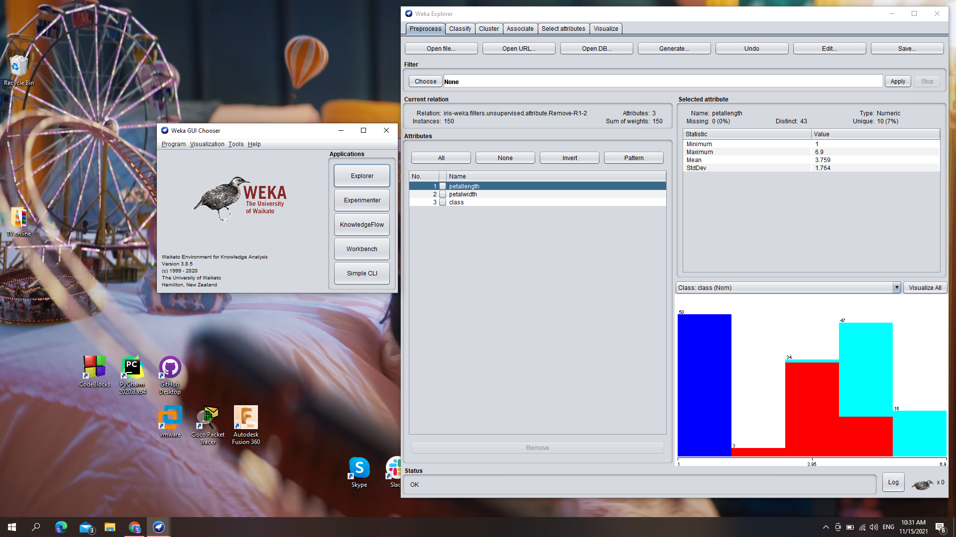

1. **Explanation for groups of preprocess tab:**

* **Filter:** this tab let us filter the data in many way (such as discrete attributes, select the suitable attribute, etc)
* **Current relation:** provides a detailed and intuitive view of the data
  + Relation: show the name of the relationship
  + Instance: number of record in the data (row)
  + Attributes: number of attribute in the data (column)
* **Attributes:** provides the attributes of the relation (has 3 columns)
  + Column 1 (No.): show the numbering of attributes
  + Column 2 (Selected cell): allow user decide which attribute to interact with (such as remove).
  + Name: display name of attribute
  + Instead of selecting one by one attribute, we can use All/None/Invert/Pattern to select attribute
  + We can use “Remove” button to remove the attribute out of the relation
* **Selected attribute:** display the feature and information of each selected attribute
  + Name: display name of selected attribute
  + Type: the type of attribute (Nominal or Numeric)
  + Missing: number and rateof missing value of selected attribute.
  + Distinct: number of distinct value of selected attribute.
  + Unique: number and rate of unique value of selected attribute.
  + Underneath these information, we can see the properties of each value for the selected attribute (including: numbering, label (value), counting sample and its total weight)
  + Moreover, at the bottom, you can see the visualize of the **class** values. If you click, visualize all, it gives you the visualization by each attribute
* **Status:**
  + Log: show history of work

1. **Explanation tabs:**

* Preprocess: manipulate the data before processing data.
* Classify: train and valid the classification model or regression model
* Cluster: clustering the data or divide data into clusters
* Associate: generate association rules from data
* Select attributes: choose the most suitable attribute base on the metric
* Visualize: graphical representation of information and data

# Requirement 2 – Begin with Weka

## Requirement 2.1 – Reading data

1. **How many instance are there?**

Number of instance: 286 instances

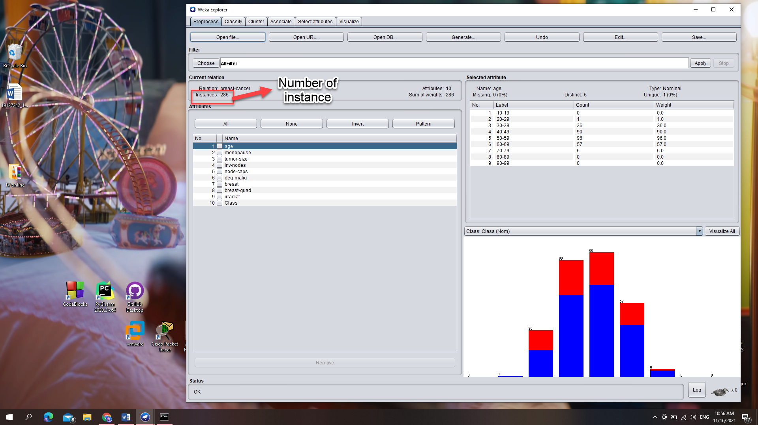

1. **How many attributes does an instance have?**

Number of attributes: 10 attributes

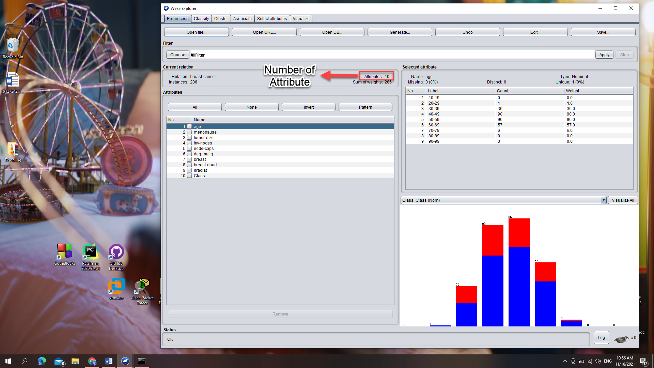

1. **Which attribute represents for the class? Can we change the class attribute and how?**

Attribute **“Class”** is being class. To change the class attribute, we select the drop down list whose label “Class” above the graph, then choose the attribute we want.

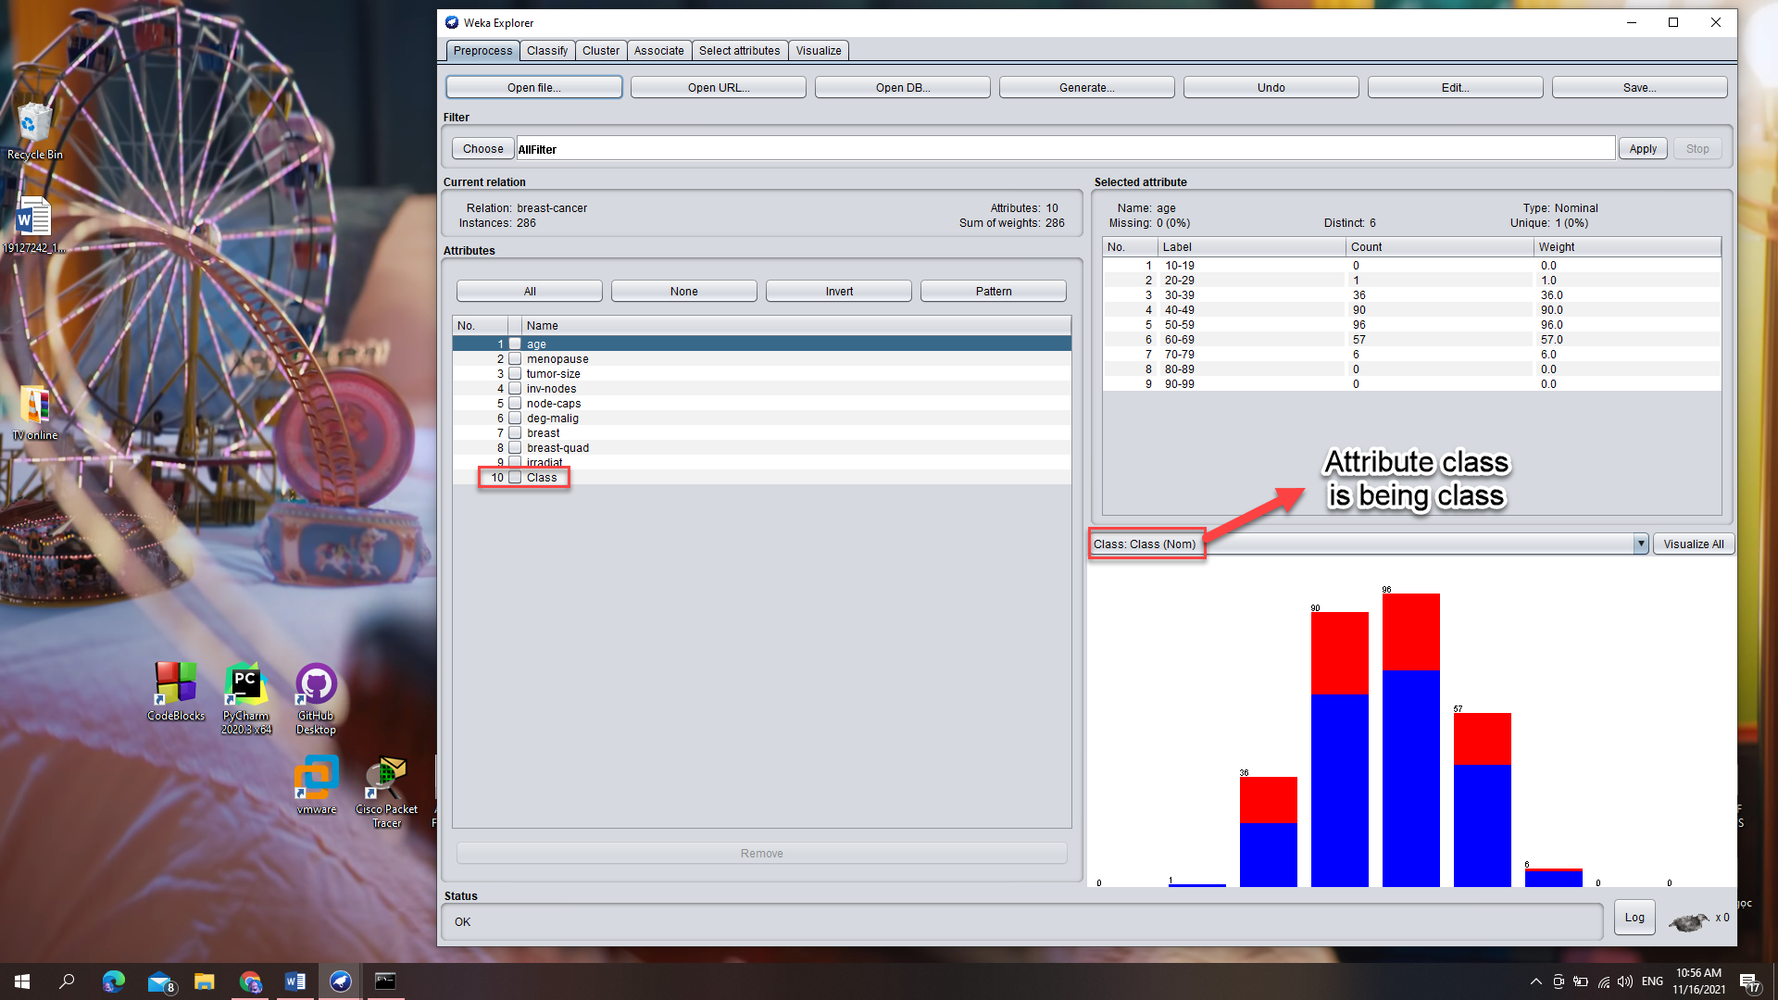

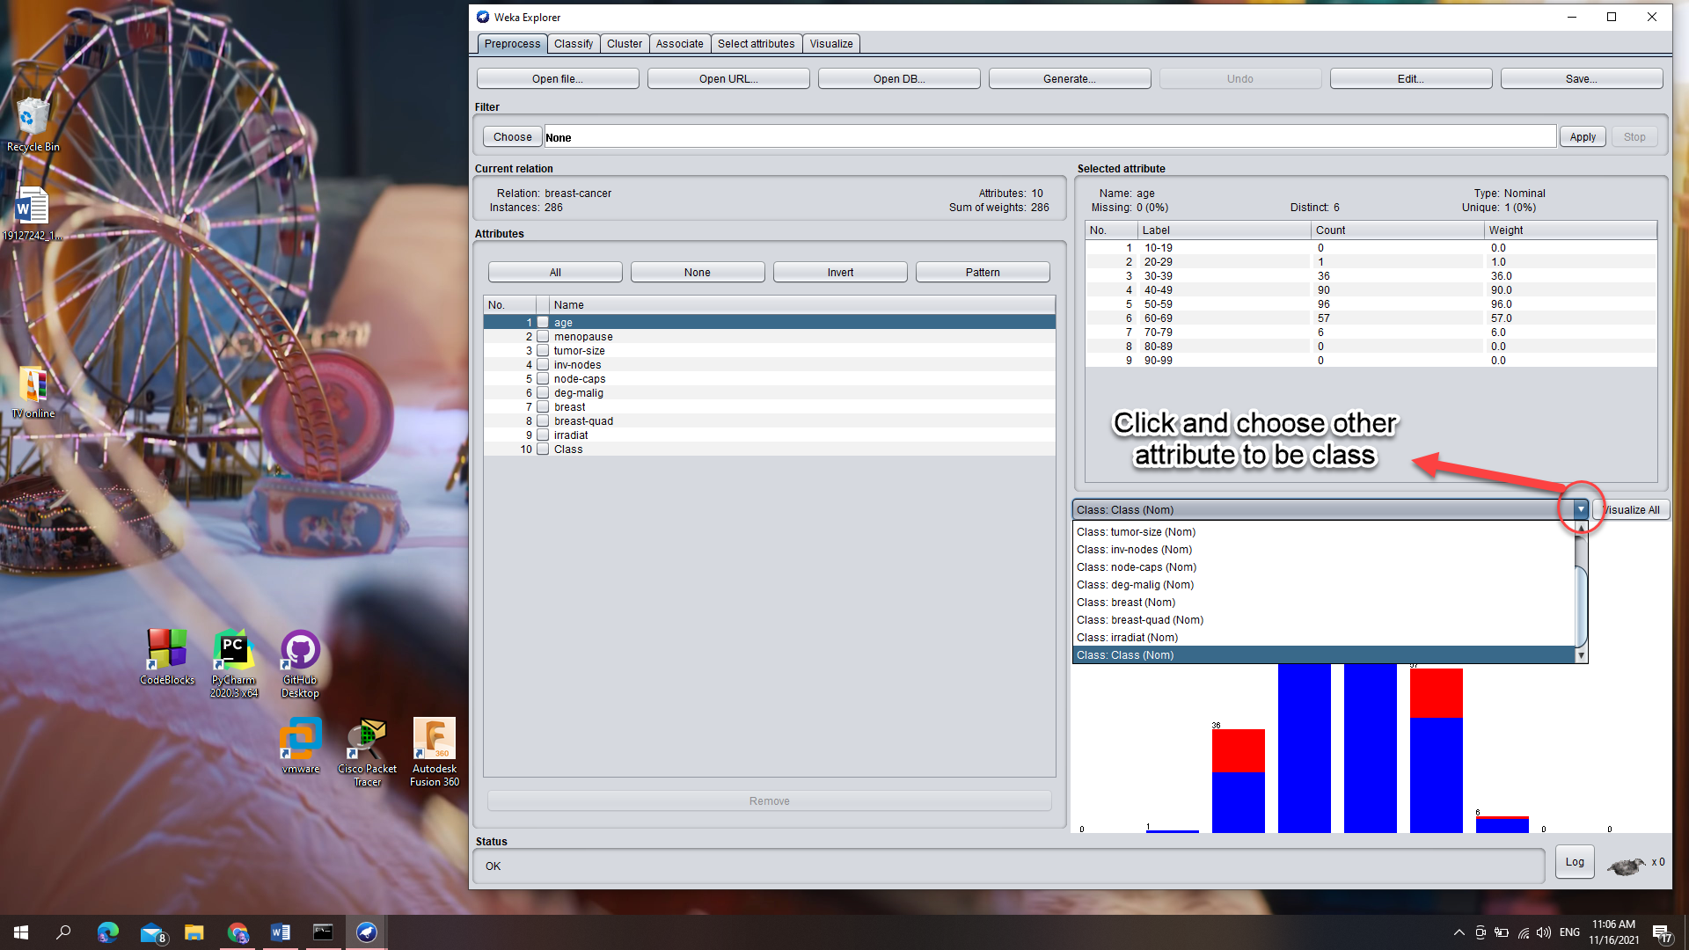

Moreover, we can see and change the attribute class by editing the data:

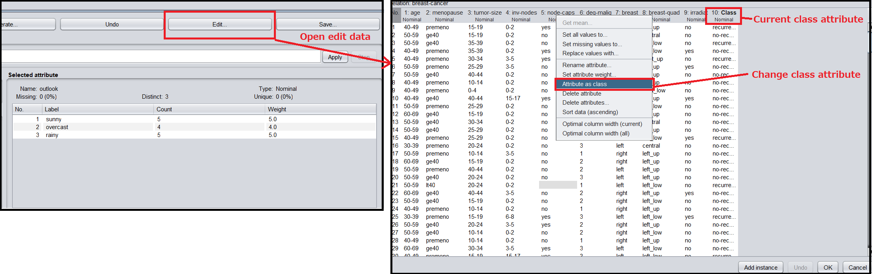

1. **For each attribute, how many missing values are there? Which attribute is the most (and the least) missing? How can we deal with the missing problem?**

* The most missing: “node-caps” attribute (8 samples, 3%)
* The least missing: Age, Menopause, Tumor-size, Inv-nodes, Deg-malig, Breast, Irradiat, Class attributes (0 samples, 0%)
* The following table show the number of missing sample for each attribute:

|  |  |
| --- | --- |
| Attribute | Missing |
| Age | 0 (0%) |
| Menopause | 0 (0%) |
| Tumor-size | 0 (0%) |
| Inv-nodes | 0 (0%) |
| Node-caps | 8 (3%) |
| Deg-malig | 0 (0%) |
| Breast | 0 (0%) |
| Breast-quad | 1 (0%) |
| Irradiat | 0 (0%) |
| Class | 0 (0%) |

* To deal with the missing problem, we can:
  + Delete the attribute whose sample is missing
  + Delete the samples whose attribute is missing
  + Data imputation: Fill the missing with mean, median, mode; or using K-NN, Linear regression; or fill with -1, -99, -999

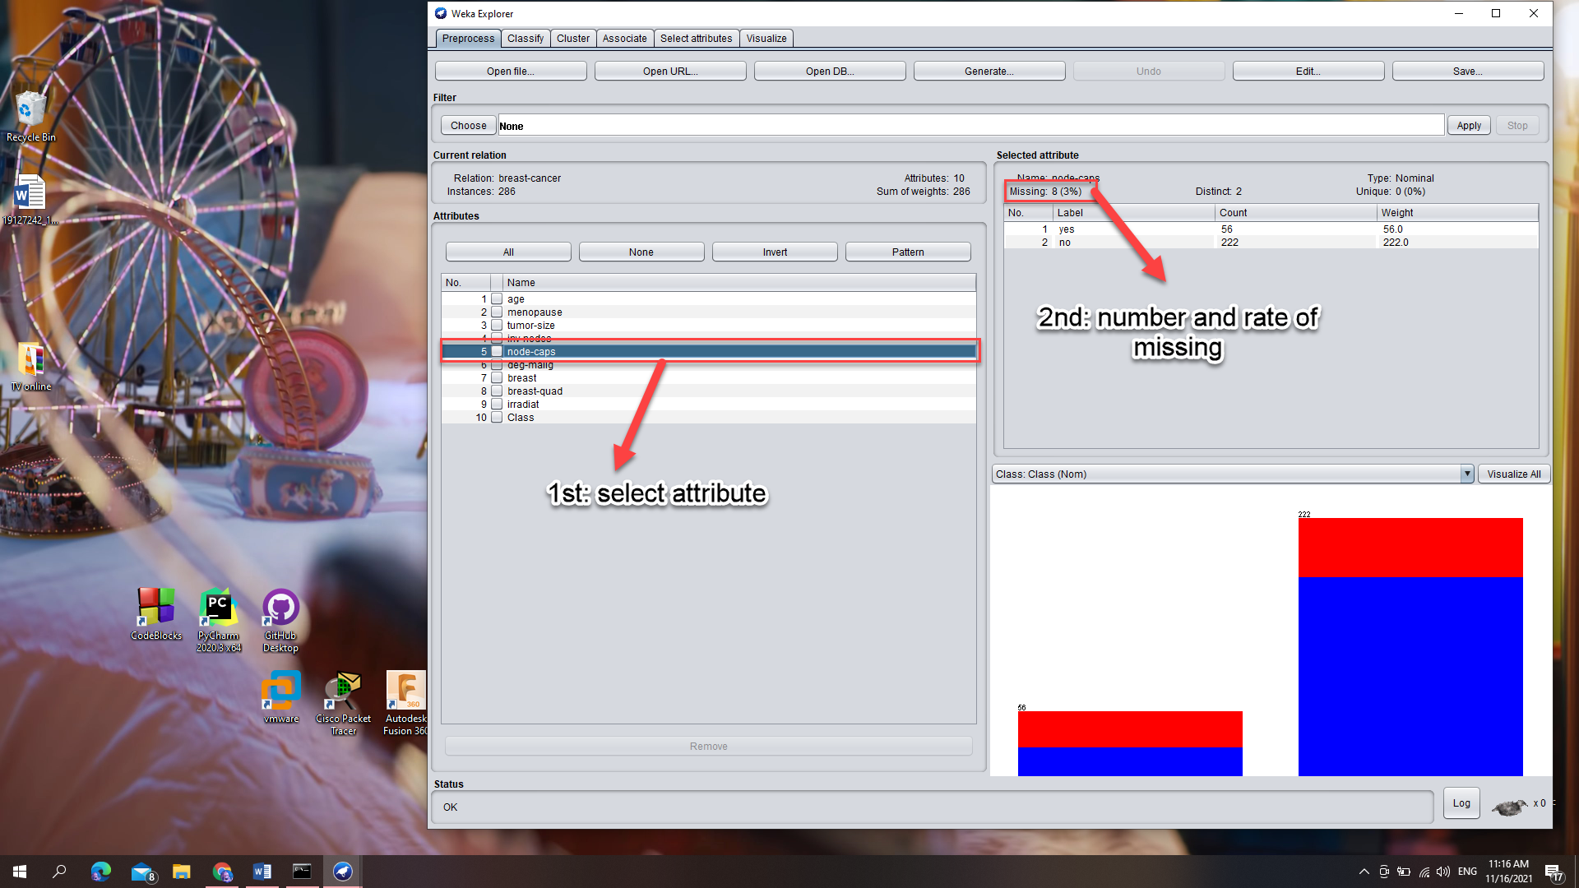

1. **Explain the meaning of graphs of Explorer window. What name is the most suitable for the graph if you have to assign to it? What is represented for the red and blue color? What does the graph represent for?**

The graph shows the distribution of the selected attribute. Each column is represented for a value of the attribute and the colors stand for the class attribute. For instance, the picture below shows that there are 152 value of left and 134 value of right one.

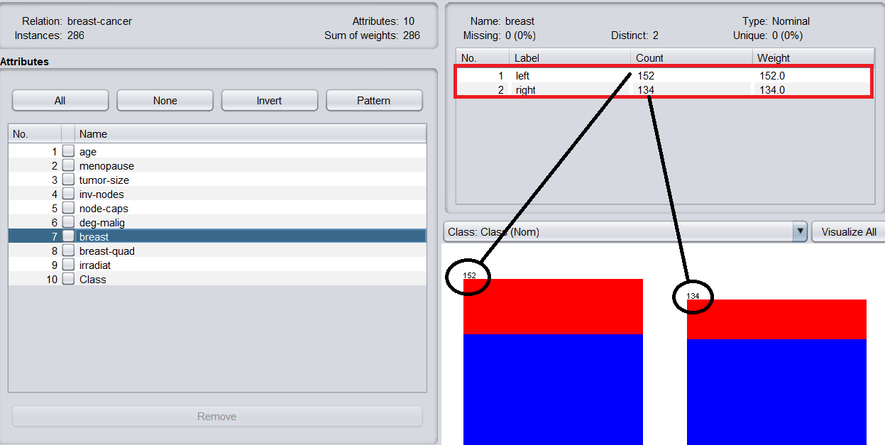

Each color represents for a value of class attribute, in this case:

* Red: recurrence-events
* Blue: no-Recurrence-events

We will know this by clicking on the class attribute and observe its color.

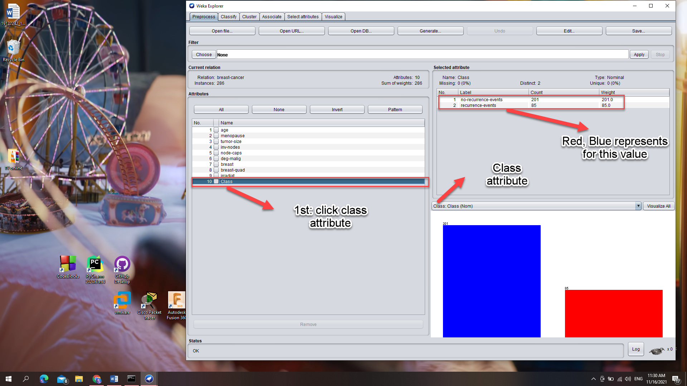

So, we can name the graph as “the split chart that compares the number of samples between two classes in terms of the selected attribute”. For example, while choosing the “breast” attribute, the graph will be named “the split chart that compares the number of samples between no-recurrence-events and recurrence-events in terms of breast”.

## Requirement 2.2 – Exploring weather dataset

1. **How many attributes are there? How many samples? What kind of datatype for each attribute? Which attribute is class attribute?**

Number of sample: 14 samples

Number of attribute: 5 attributes

In “selected attribute” tab, we can see the “Type” of each attribute. The datatypes of each attribute are:

* Nominal: outlook, windy, play
* Numeric: temperature, humidity

Class attribute:play

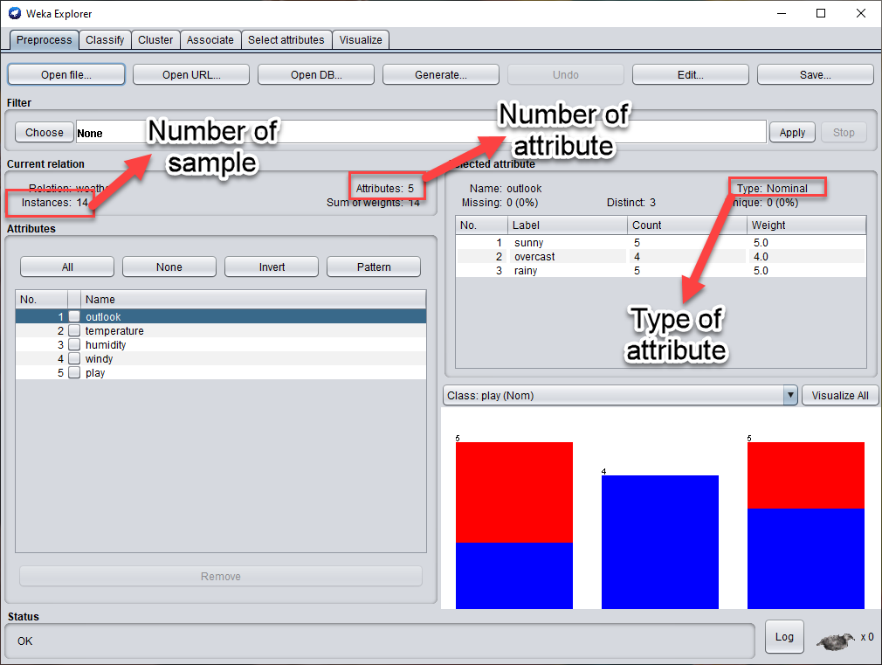

1. **List down five-number summary of tempurature and humidity. Does Weka provides any feature to calculate this?**

Weka does not provide any feature that have us the calculate the five-number summary of the attribute. To find these summary, we sort the data ascendingly using the “edit” feature:

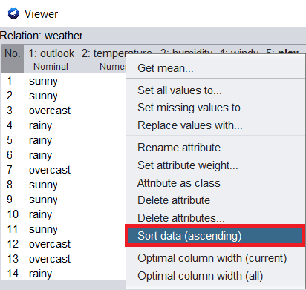

For the tempurature:

* Min (0%): 64
* Q1 (25%): 69
* Median (50%): 72
* Q3 (75%): 80
* Max (100%): 85

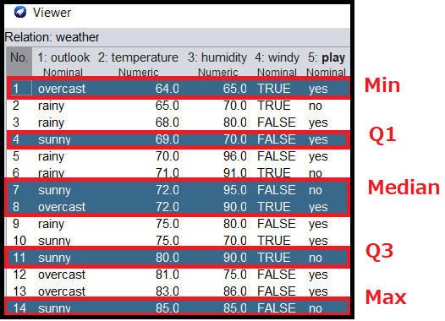

For the humidity:

* Min (0%): 65
* Q1 (25%): 70
* Median (50%): 82.5
* Q3 (75%): 90
* Max (100%): 96

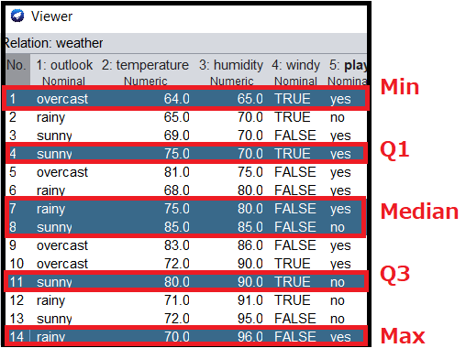

1. **Alternatively look at the graph of each attribute and take screenshot?**

Click “Visualize All” to look at the graph of each attribute.

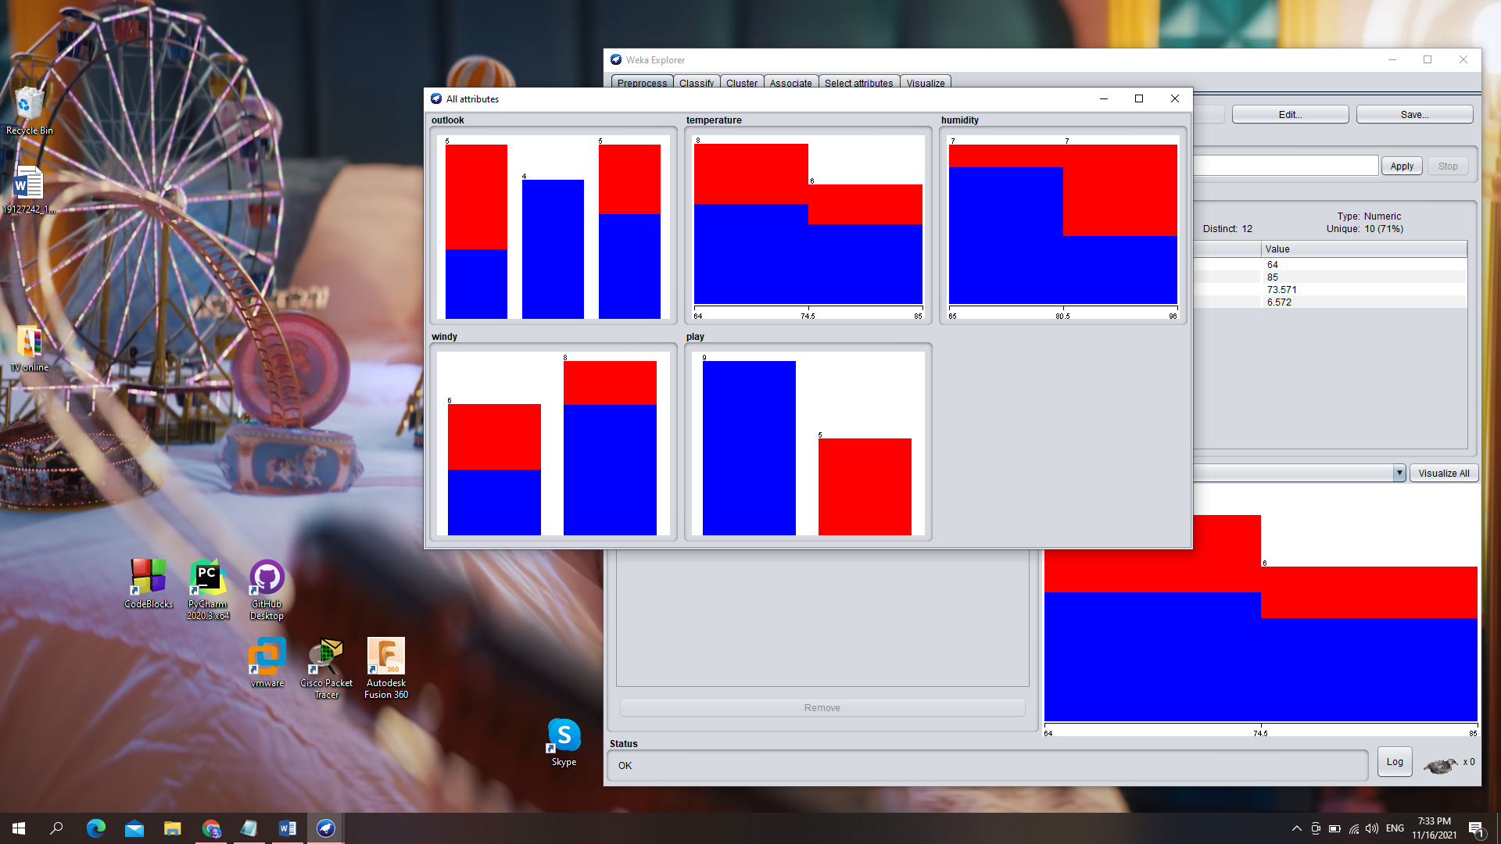

1. **What is the terminology we call the graph in “Visualize” tab? Choose the appropriate jitter to see the distribution better? In your opinion, which is the pair of different attributes that one attribute correlate with the other one?**

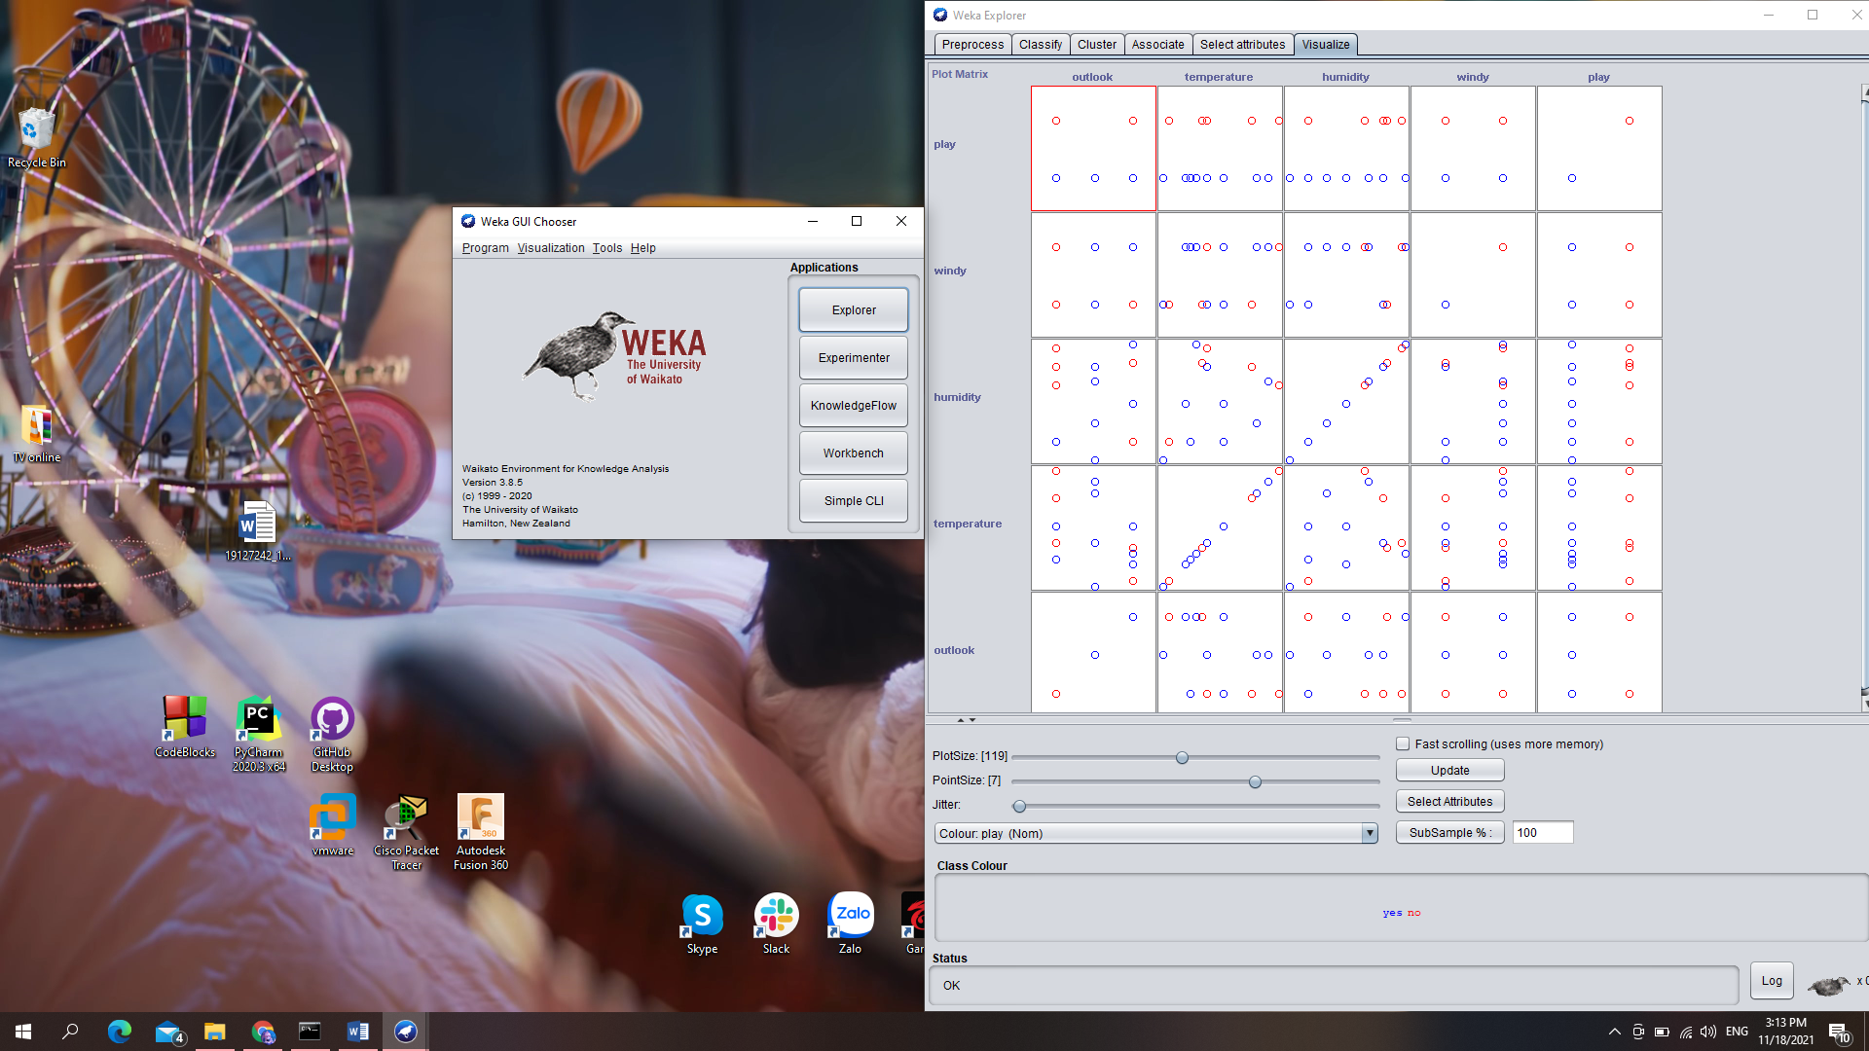

The terminology for this graph is called “pairwise scatterplot matrix”. In our opinion, the pair of attributes which have the most correlative is “Outlook” and “Tempurature” since the tempurature is low whenever it rains; and high as sunny.

## Requirement 2.3 – Exploring German credit dataset

1. **What did the comment of the dataset say? How many instances and attributes are there? Describe 5 attribute arbitrarily (must have both discrete and continuous)**

Comment of the dataset said:

* Section 1: title of data (German credit data)
* Section 2: source information (Dr. Hans Hofmann, etc)
* Section 3: number of instance which is 1000 instances
* There are 2 dataset (categorical and numerical)
* Section 6: the number of attribute. We use data “credit-g.arff”, don’t use “credit-g.numer.arff”
  + File “german”: 20 attributes (7 numerical, 13 categorical) without class attribute
  + File “german.numer”: 24 attributes (24 numerical) without class attribute
* Section 7: describes the meaning of attributes for “german” (credit-g.arff) file
* Section 8: provide the cost matrix for class attribute; and value for attributes
* Notice that the section 7 only provides the meaning of attribute, not their values. Their values is relabeled in section 8.

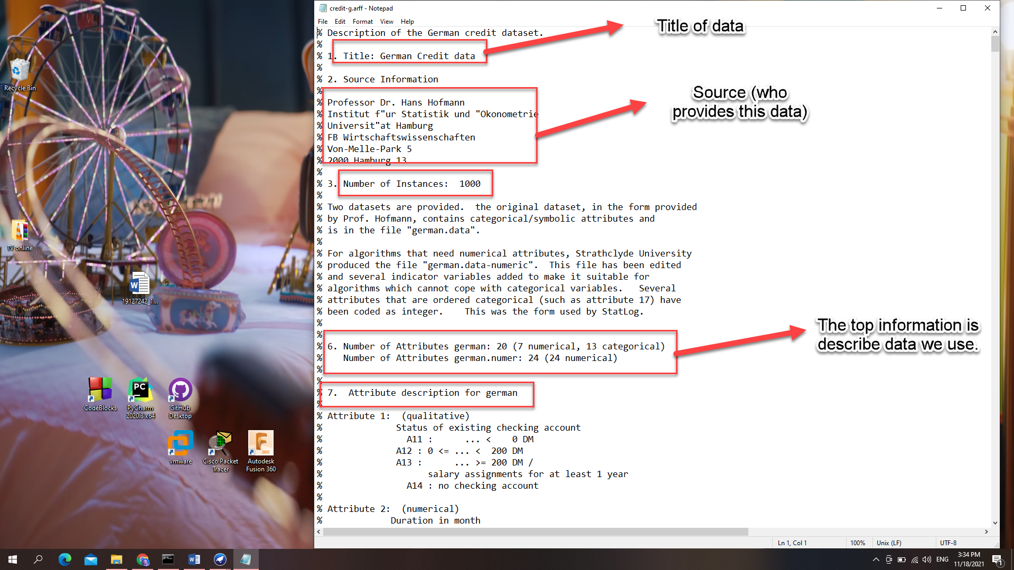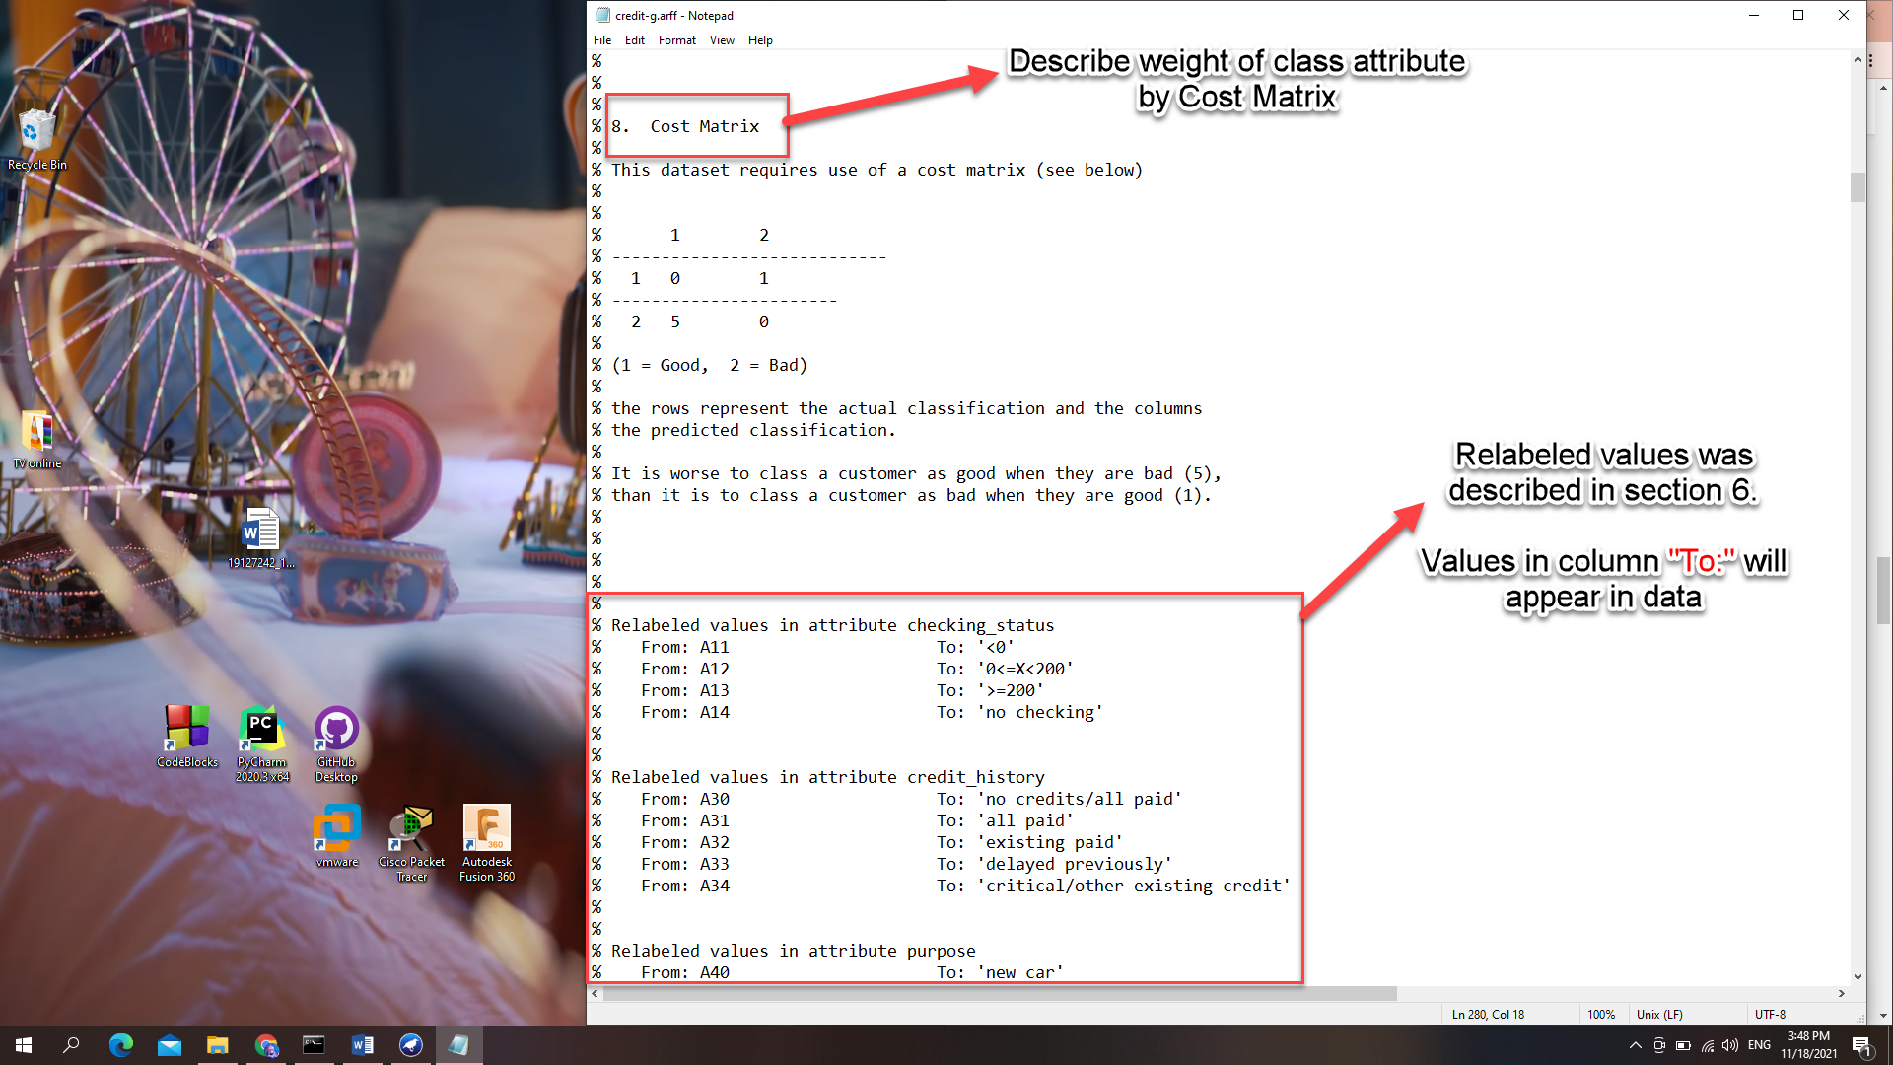

**Describe 5 attributes:**

* Attribute 5 (numerical):
  + Credit Amount
* Attribute 6 (qualitative):
  + Saving account/bonds
  + Have 5 values:
    - Value 1 (A61): less than 100 DM
    - Value 2 (A62): from 100 DM to 500 DM
    - Value 3 (A63): from 500 DM to 1000 DM
    - Value 4 (A64): More than 1000 DM
    - Value 5 (A65): unknown/no savings account
* Attribute 7: (Qualitative)
  + Present employment since a period of time
  + Have 5 values:
    - Value 1 (A71): unemployed
    - Value 2 (A72): less than 1 year
    - Value 3 (A73): from 1 year to 4 years
    - Value 4 (A74): from 4 years to 7 years
    - Value 5 (A75): more than 7 years
* Attribute 8: (numerical)
  + Installment rate in percentage of disposable income
* Attribute 9: (qualitative)
  + Personal status and sex of the sample
  + Have 5 values:
    - Value 1 (A91): male and divorced/separated
    - Value 2 (A92): female and divorced/separated/married
    - Value 3 (A93): male and single
    - Value 4 (A94): male and married/widowed
    - Value 5 (A95): female and single

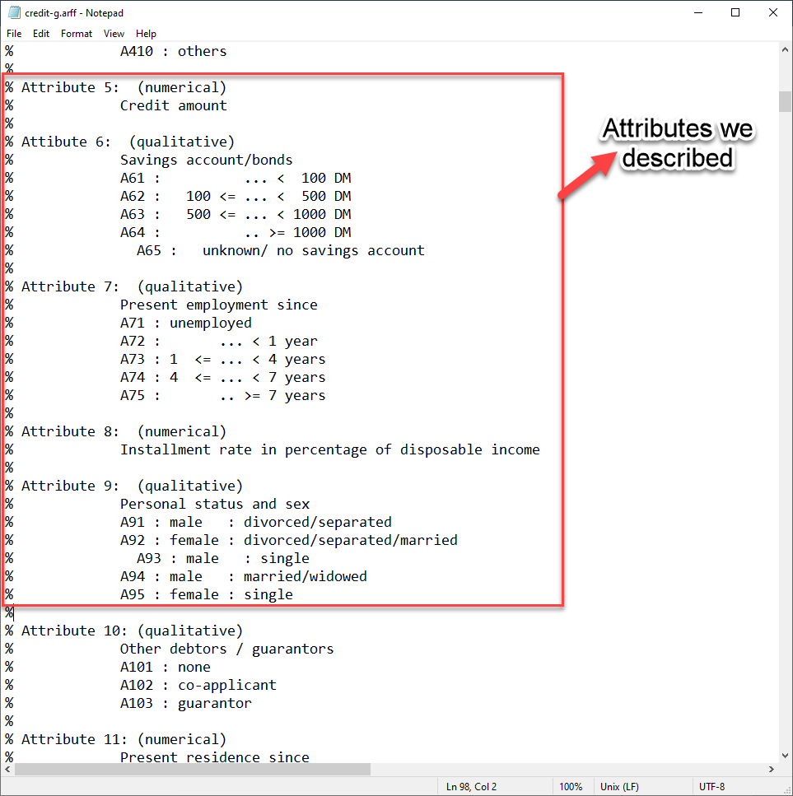

1. **Which attribute is the class attribute? Evaluate the distribution of classes, means that is it balance or being skew?**

**“Class”** is name of the class attribute and the distribution of classes is **skew** **to “good”** value.

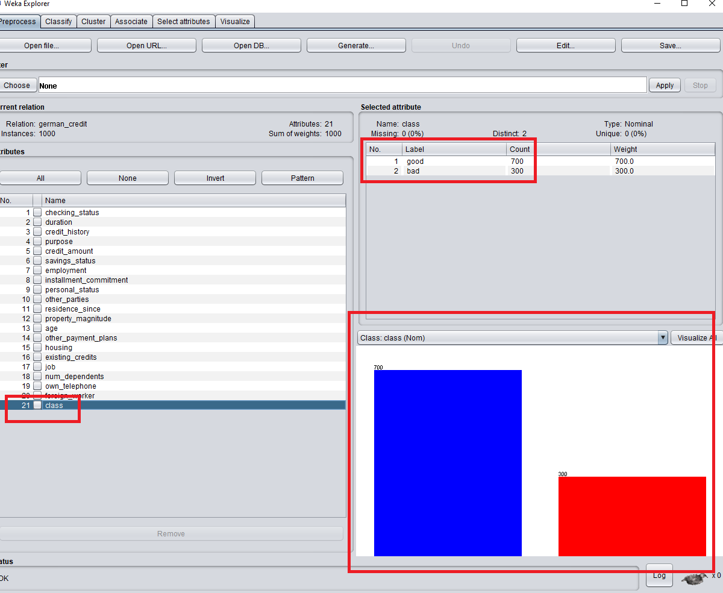

1. **Using the “Select attribute” tab, list down and describe briefly for each method**
2. Correlation Based Feature Selection (CorrelationAttributeEval):

Calculate the correlation (Pearson’s) between each attribute and the class attribute. There are three kinds of Pearson’s correlation: Positive, Neural and Negative.

After using this technique, we can choose the moderate to high positive or negative correlation and drop the neural (low correlation) one.

For instance, we tested this feature on the weather dataset for the “outlook” class and achieved that the most correlative attribute is “tempurature”.

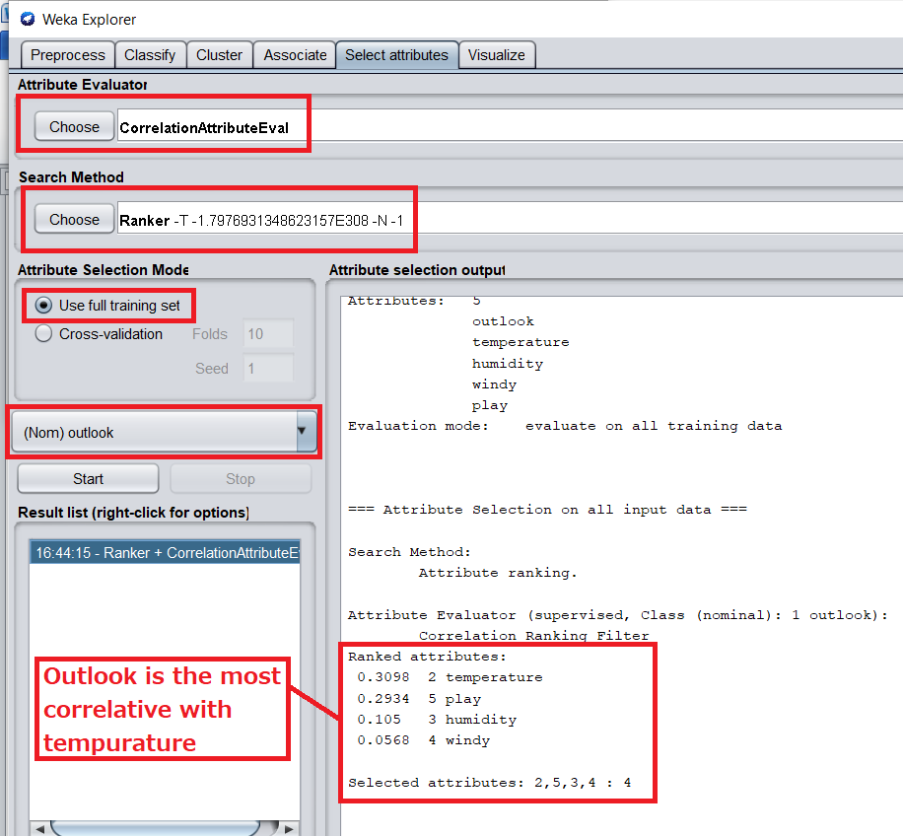

1. Information Gain Based Feature Selection (InfoGainAttributeEval):

Calculate the information gain (also called [entropy](https://en.wikipedia.org/wiki/Entropy_(information_theory))) for each attribute for the output variable. The value is in range from 0 (no information) to 1 (maximum information). Those attributes that contribute more information will have a higher information gain value which can be selected. On the other hand, the low information gain attribute can be removed. This also used to execute the ID3 algorithm (Decision tree).

1. Learner Based Feature Selection (WrapperSubsetEval):

The subset that results in the best performance is taken as the selected subset one. It runs the classifier with cross-validation and choose based on the picked metric.

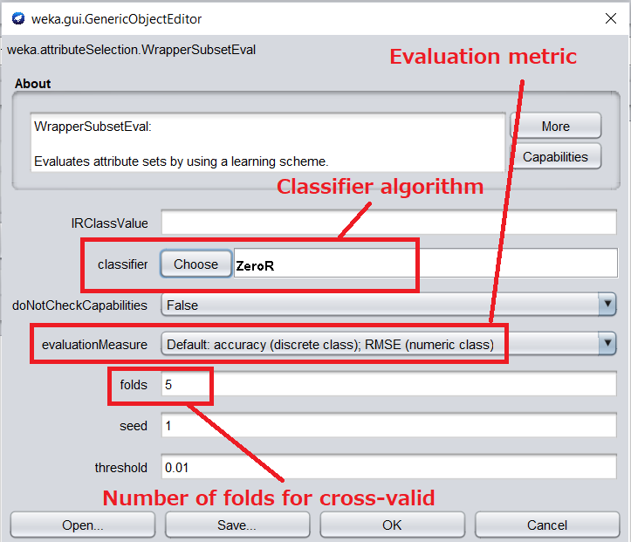

1. Correlation Based Feature Selection Subset (CfsSubsetEval):

This method evalutes how correlative that a subset (of attributes) to the class attribute. The subsets whose element are less intercorrelative, but the subset highly correlated to the target class are preferred (elements should as independent as possible).

1. Gain Ratio Attribute evaluation (GainRatioAttributeEval):

This method measures the significance of attributes with respect to target class on the basis of gain ratio. It can be calculated by the following formula:



Where  represents for the Entropy function

1. Classifier Attribute Evaluation (ClassifierAttributeEval):

Evaluates the worth of an attribute by using a user-specified classifier.

1. Classifier Subset Evaluator (ClassifierSubsetEval):

Evaluates attribute subsets on training data or a separate hold out testing set. After that it uses the given classifier (by user) to estimate the set of attribute

1. One R Attribute Evaluation (OneRAttributeEval) :

Evaluates the worth of an attribute by using the OneR classifier.

1. Principal components:

Performs a principal components analysis (PCA) and transformation of the data

1. Relief F Attribute Evaluation (ReliefFAttributeEval):

Evaluates the worth of an attribute by repeatedly sampling an instance and considering the value of the given attribute for the nearest instance of the same and different class.

1. Symmetrical Uncert Attribute Evaluation (SymmetricalUncertAttributeEval) :

Evaluates the worth of an attribute by measuring the symmetrical uncertainty with respect to the class.

1. **Which filter should we use to find out 5 most correlative attributes (to the class attribute)? Describe step-by-step and include the screenshot**

To find the most correlative attributes, we do the following step:

* Step 1: Click “Select Attribute” tab
* Step 2: Choose Attribute Evaluator “Correlation Attribute Eval”
* Step 3: Choose class attribute which is “class”
* Step 4: Choose Search Method “Ranker” with number to select is Top-5
* Step 5: Click Start

And the result show top-5 attributes are: checking_status, duration, credit_amount, savings_status and housing.

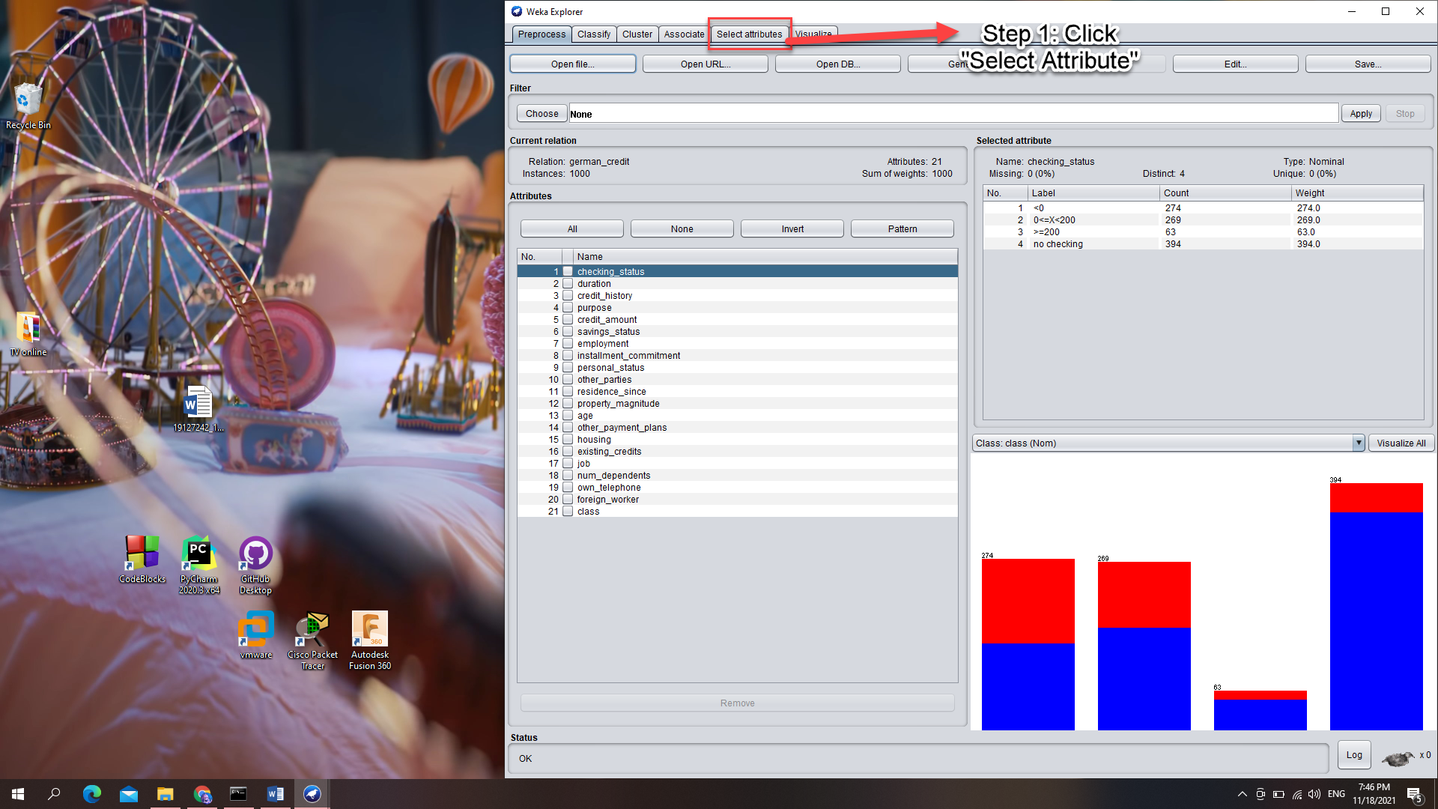

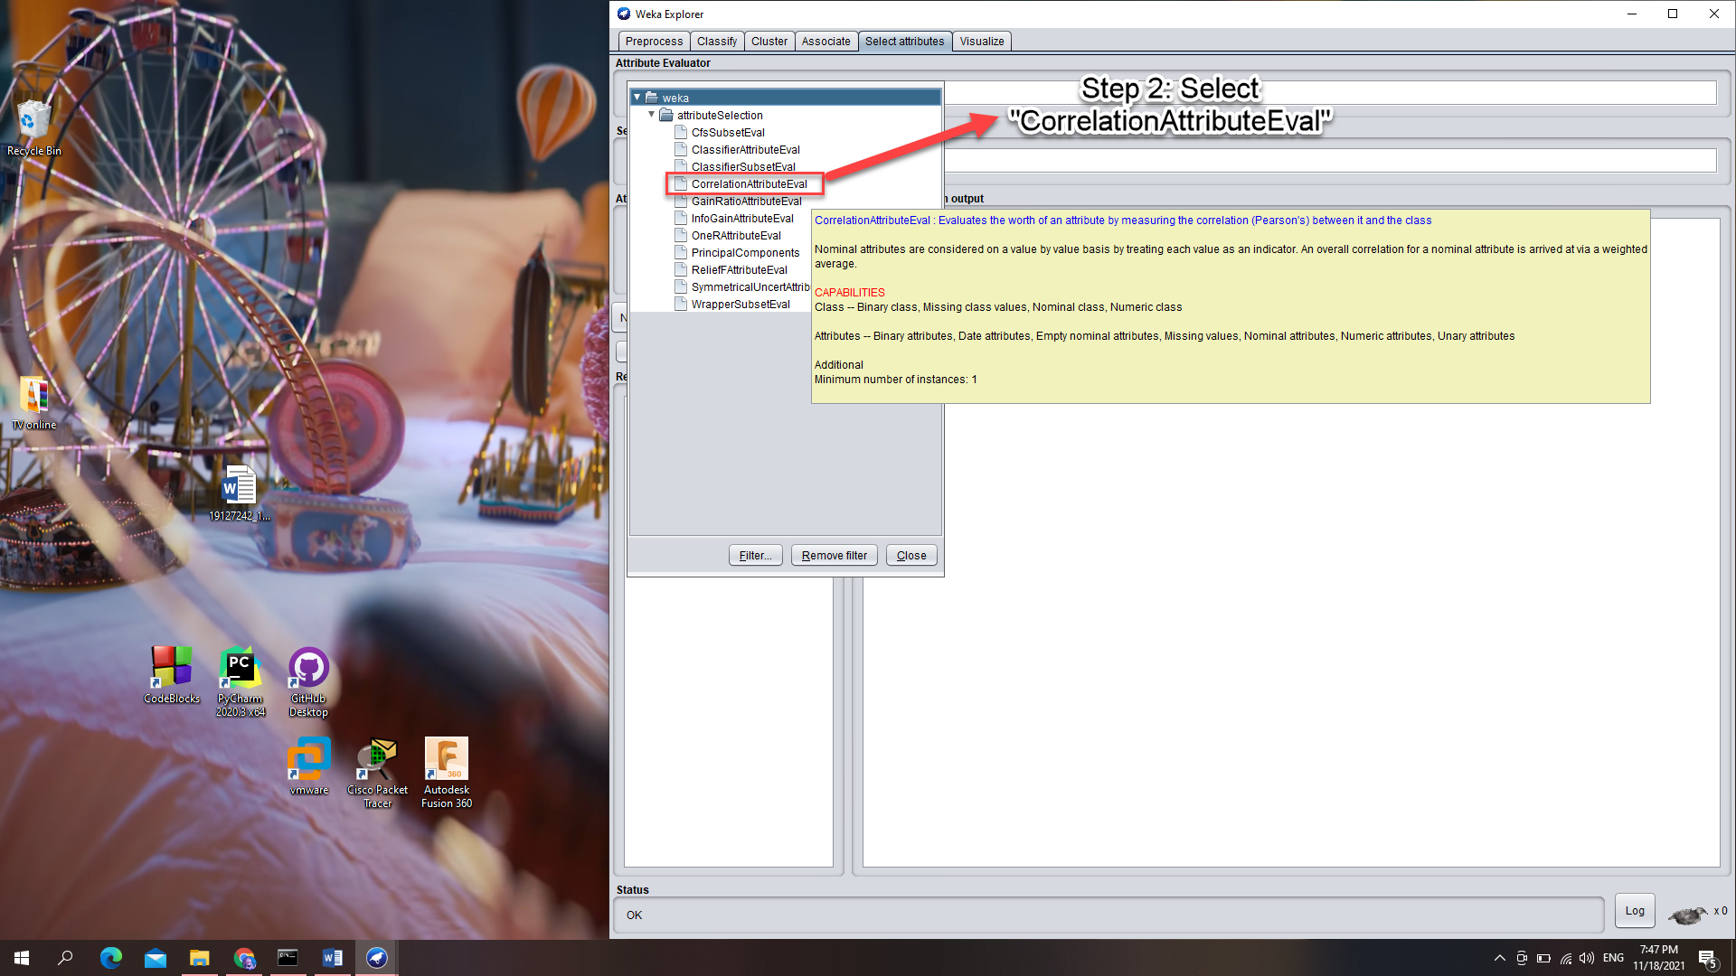

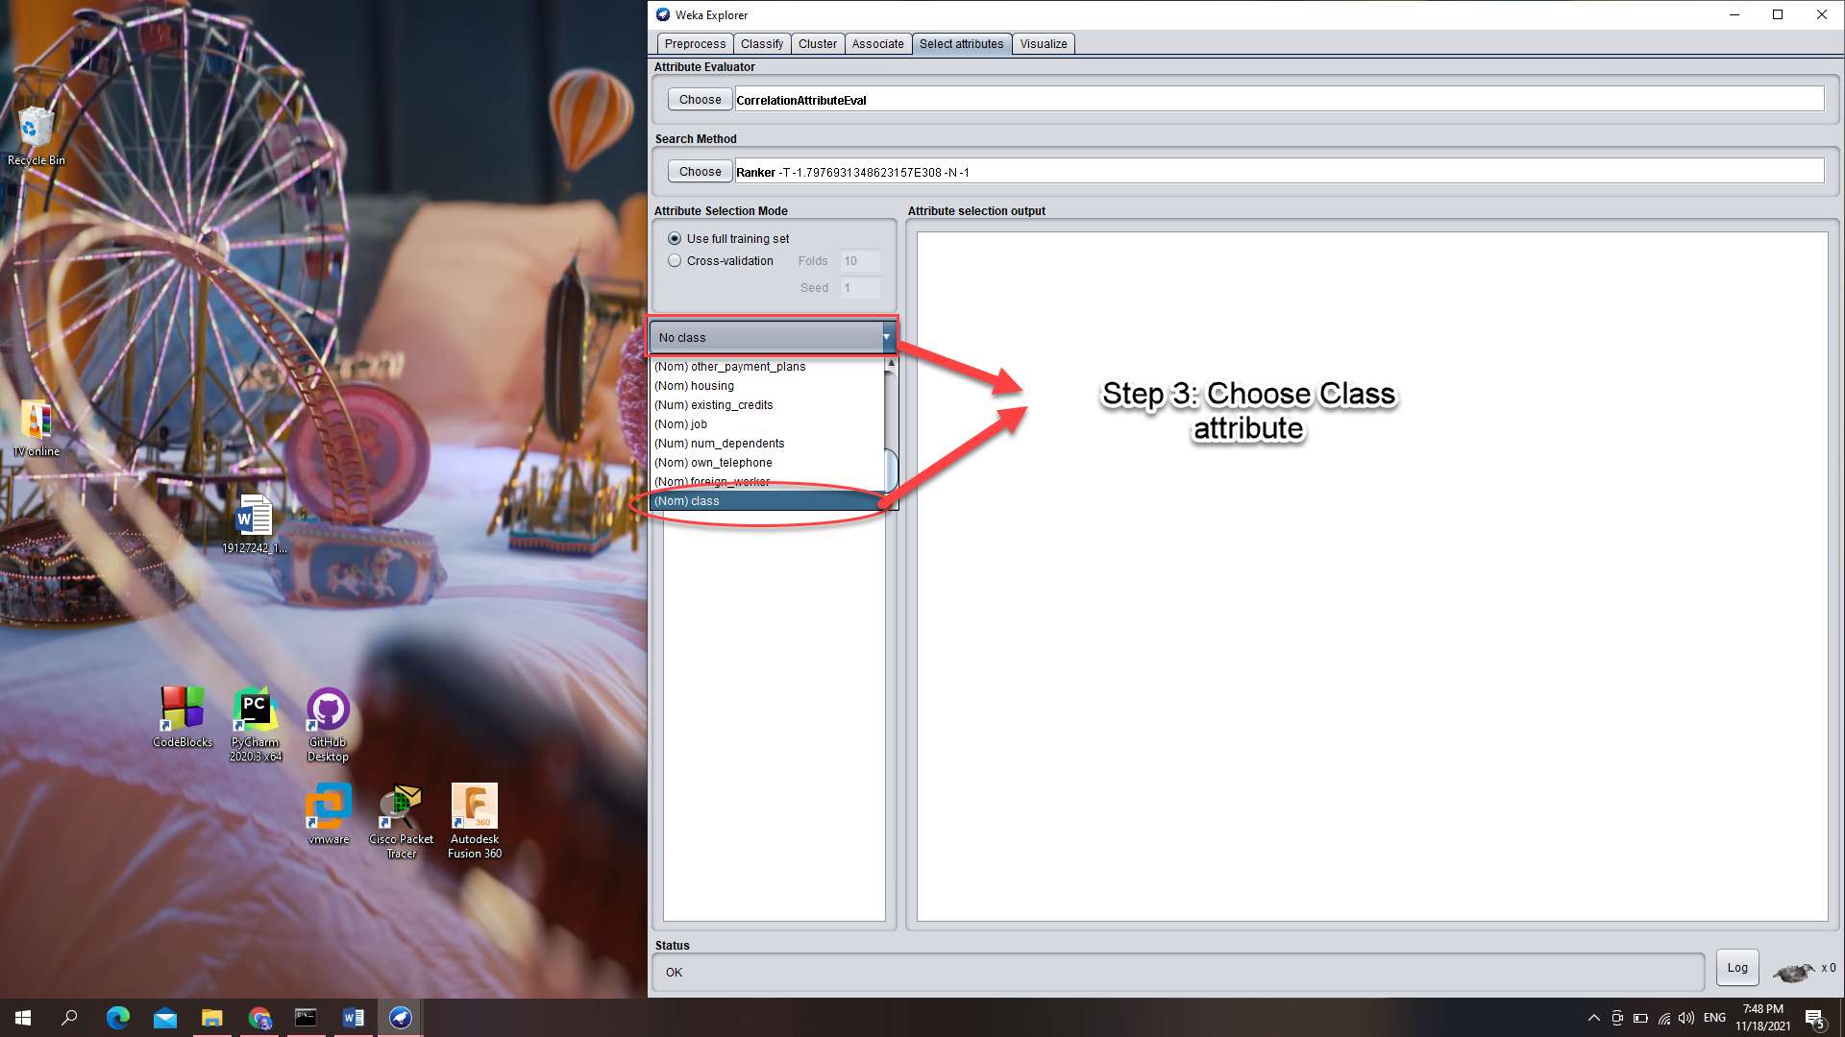

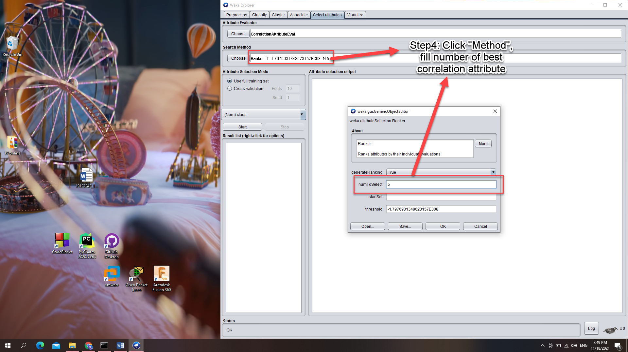

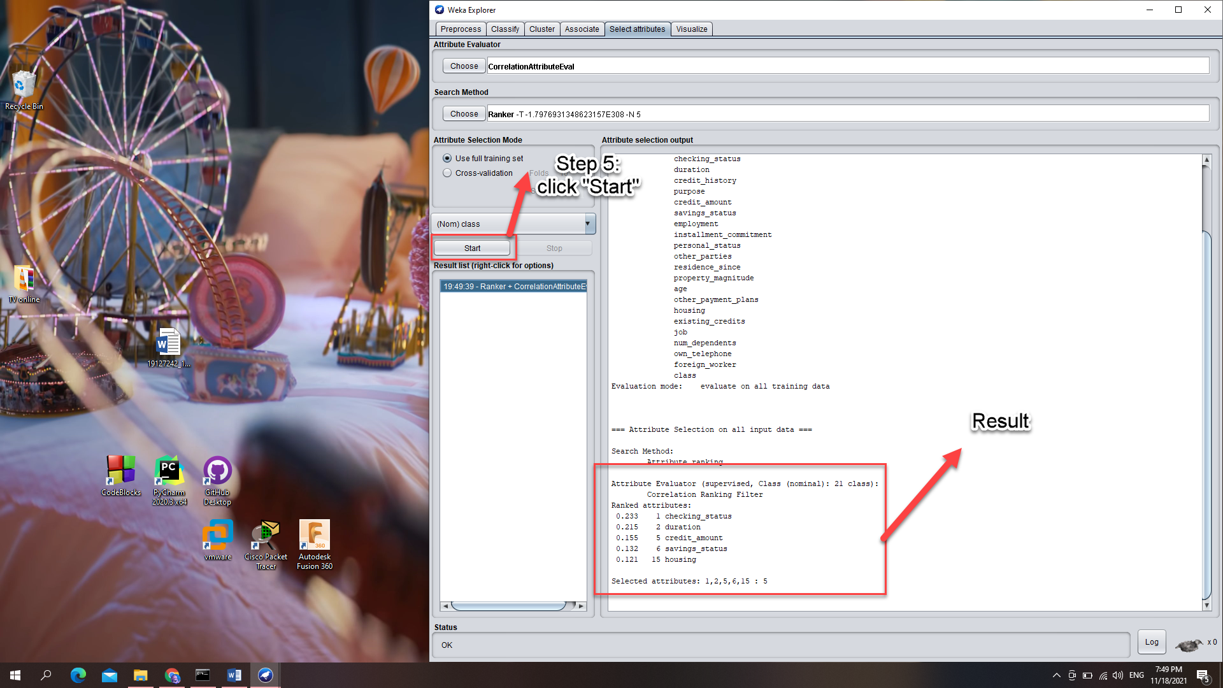

# Requirement 3 – Preprocessing implementation

Firstly, in our solution, we have written a readme document (“README.md”) to instruct the user how to use the source code. Moreover, in readme document, we also jot down the implementation document. In this task, we divide our repository into folder:

* data: contains input and output data
* src: stores the main solution
* readme.md: document for usage and implementation

In our testing phase, we use the given data “house-prices.csv” for testing and compare the result with the one given by WEKA and excel.

## List missing

Firstly, we list out the missing feature of the house-prices data and achieve this result.

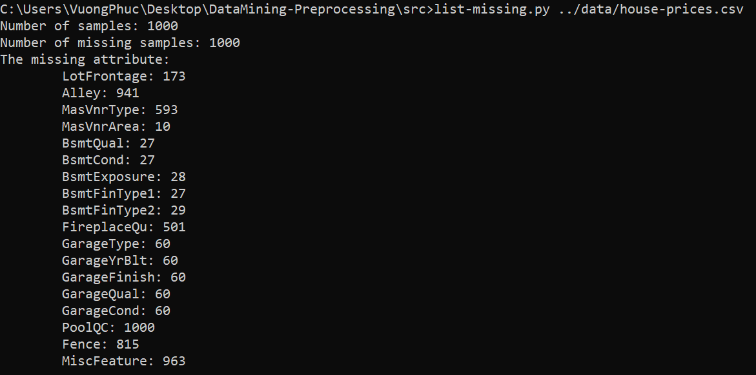

Comparing to WEKA, we have the same number of samples and number of missing sample. Moreover, the number of missing sample is 1000 as all values of attribute PoolQC are missing.

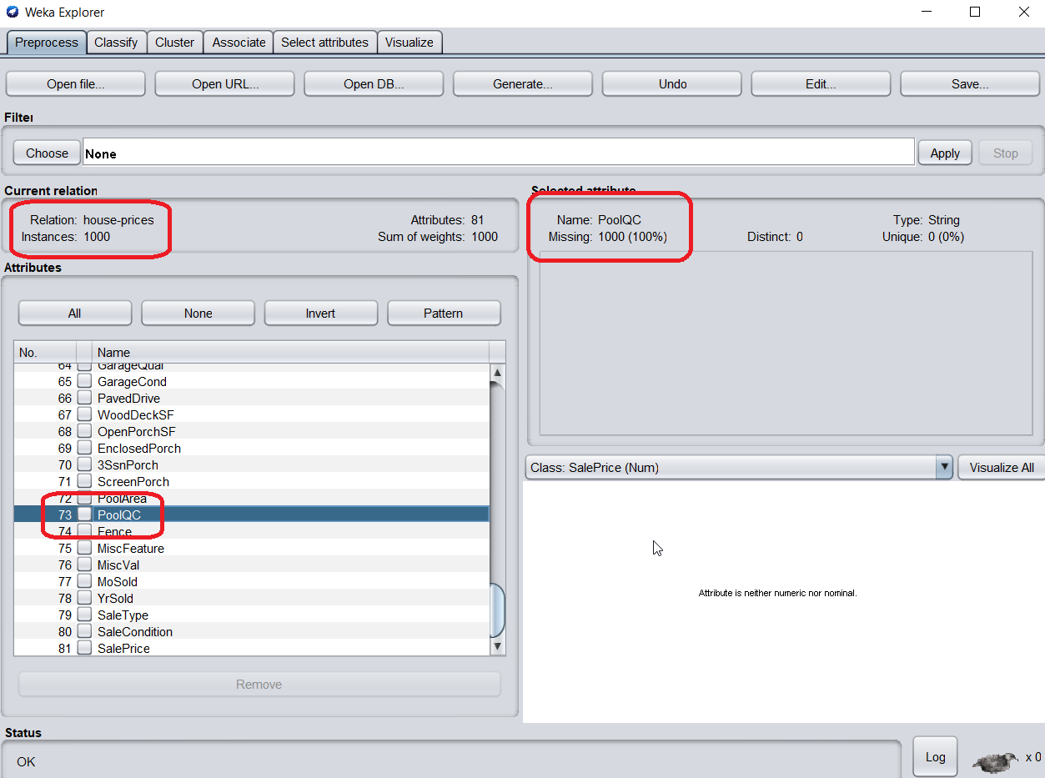

And we check for some attributes which is missing using Weka:

* LotFrontage: 173 missing samples

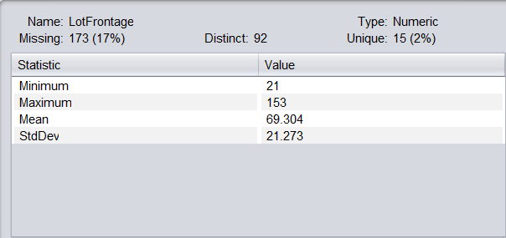

* Alley: 941 missing samples

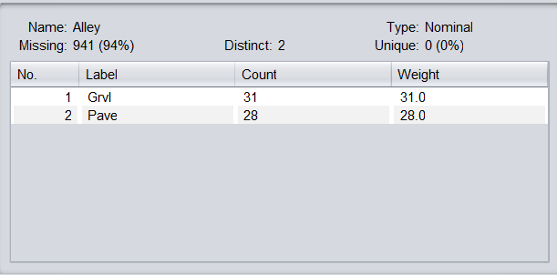

* MasVrnType: 593 missing samples

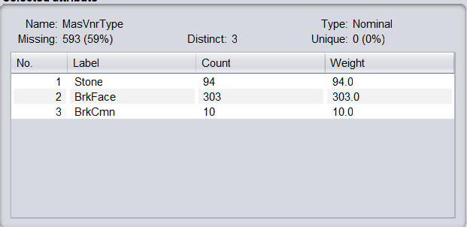

## Imputing

Now, we doing the imputation for missing data. First thing first, we test that the source code must notify whenever the user pick the wrong method. In particularly, we try to impute the Alley attribute which is a nominal with the median method:

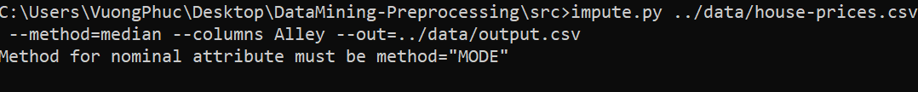

As the Alley attribute is nominal, we use the mode method to impute this attribute and using mean method for the LotFrontage attribute.

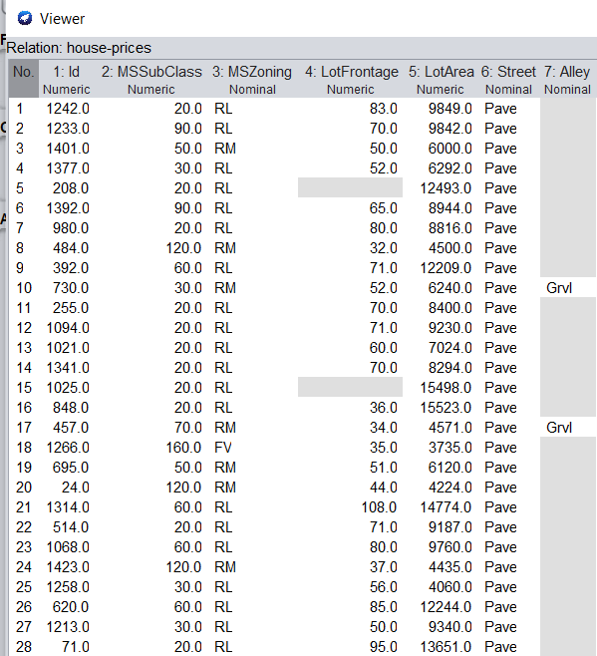

Now, we create the file “output1.csv” after impute the Alley attribute and continue with that file to impute for the LotFrontage attribute:

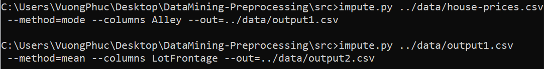

And this is the data after being imputed:

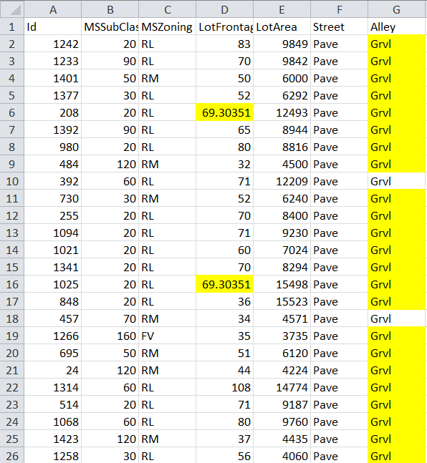

To do the imputation in weka, we use the unsupervised filter which named “ReplaceMissingValue”. This filter, will replace all the missing nominal value with mode method, and missing numeric value with mean method.

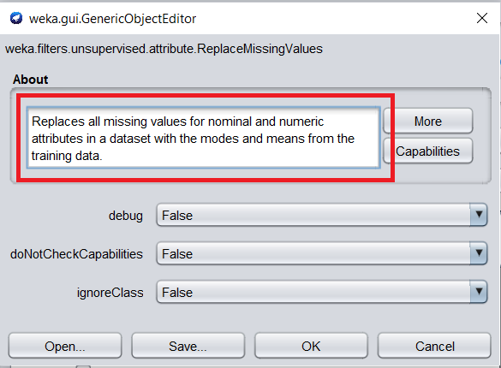

Finally, we observed that two result are the same:

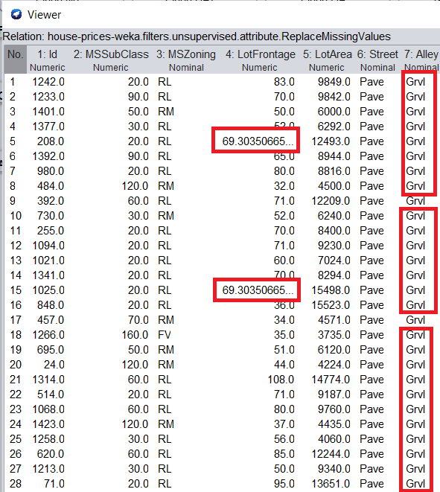

## Remove sample and attribute

### Remove sample with threshold

In this section, for testing, we use excel to calculate the number of missing value for one-by-one sample (using COUNTBLANK). And then, we observed that the number of missing value is in range of [2,16]. So we testing for remove the sample whose number of missing value is greater than 3 (which means we only take the samples missing 2 and 3 values).

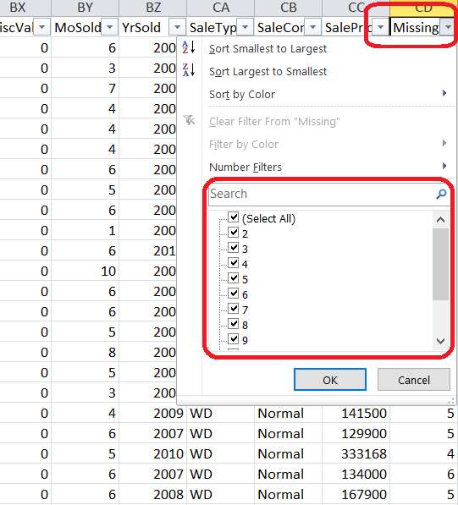

To count the number of samples whose number of missing value is 2, or 3; we use countif formula of excel. After counting, we see that it has **34 samples**. Lastly, we calculate the threshold which is , since we only remove sample whose rate is greater than threshold, we choose  to be our threshold.

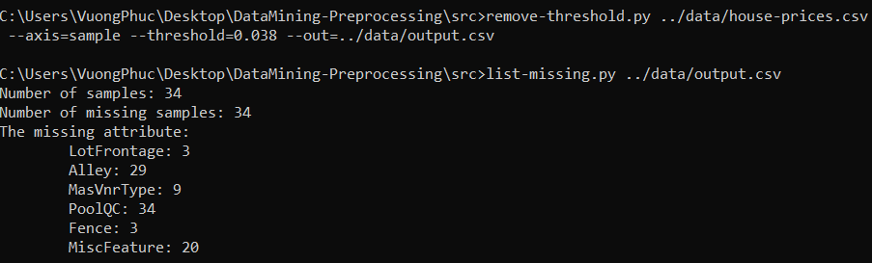

### Remove attribute with threshold

From the list of missing attribute, we can calculate the threshold to remove attributes. For instance, we try to remove attributes: Alley, MiscFeature and PoolQC. The minimum number of missing sample is 941 samples (corresponding to Alley). So the threshold we need is , however this feature only remove whenever the rate is **greater**. In conclude, the threshold must be .

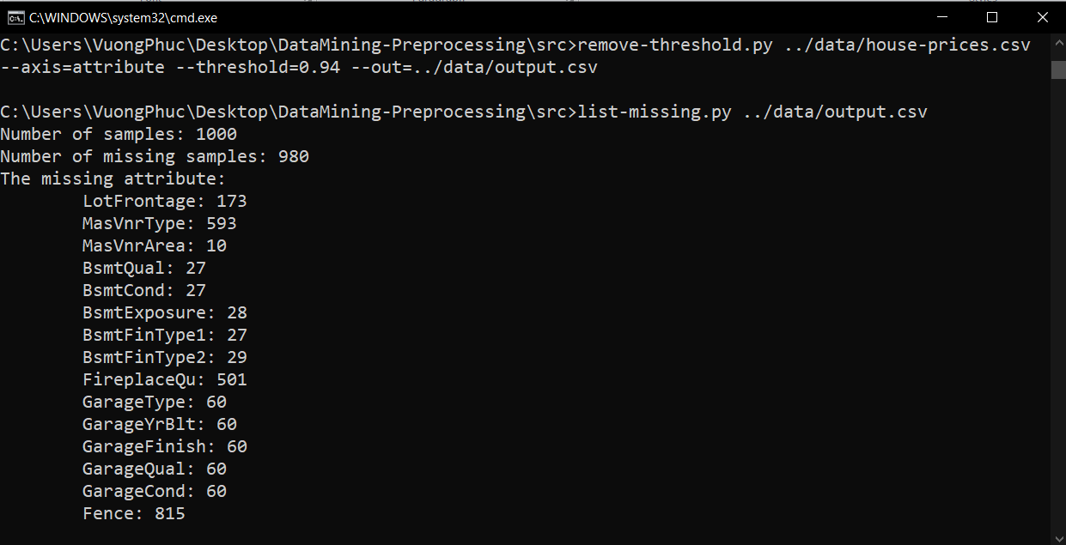

### Remove duplicated samples

We can easily test this feature by removing and listing down the number of rest samples. After removed, we only have 716 samples left.

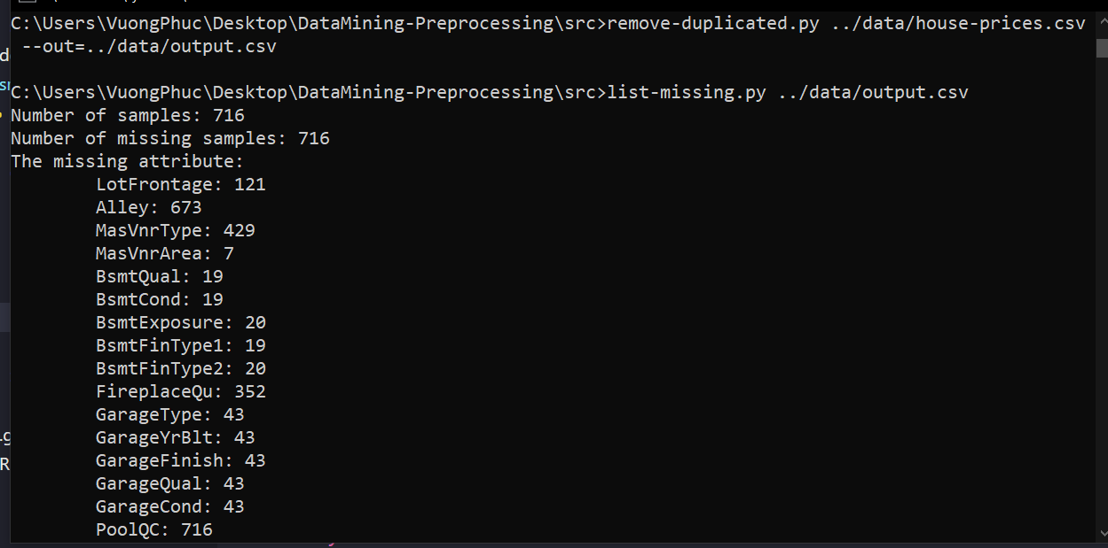

In Weka, to remove duplicated samples, we use RemoveDuplicates filter in unsupervised/instance:

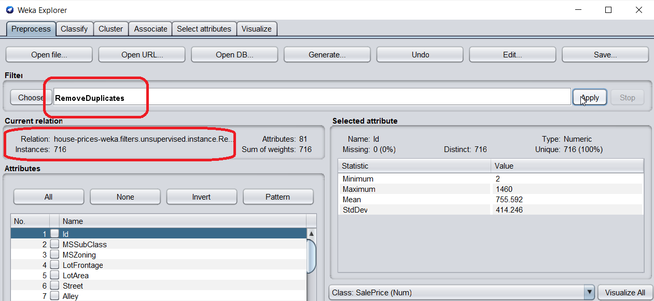

## Normalizing

We used excel to normalize the “SalePrice” attribute by finding its properties:

* Min: using min formula
* Max: using max formula
* Mean: using average formula
* Std: using stdevpa formula

Then we normalize for both methods:

* Z-score: using standardize formula
* Min-max: doing manually

For the normalization, we achieve some head samples:

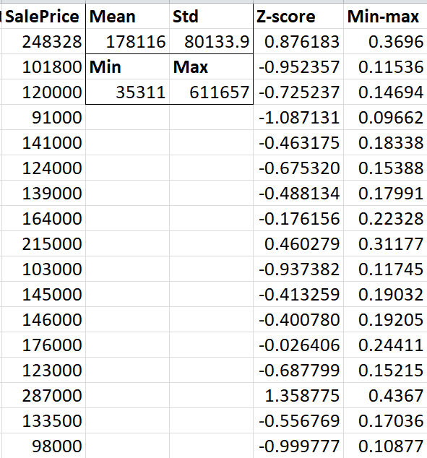

Then we use our source code to do the normalization for each method:

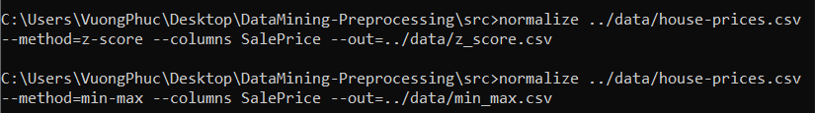

Comparing two results, we see that they are matched:

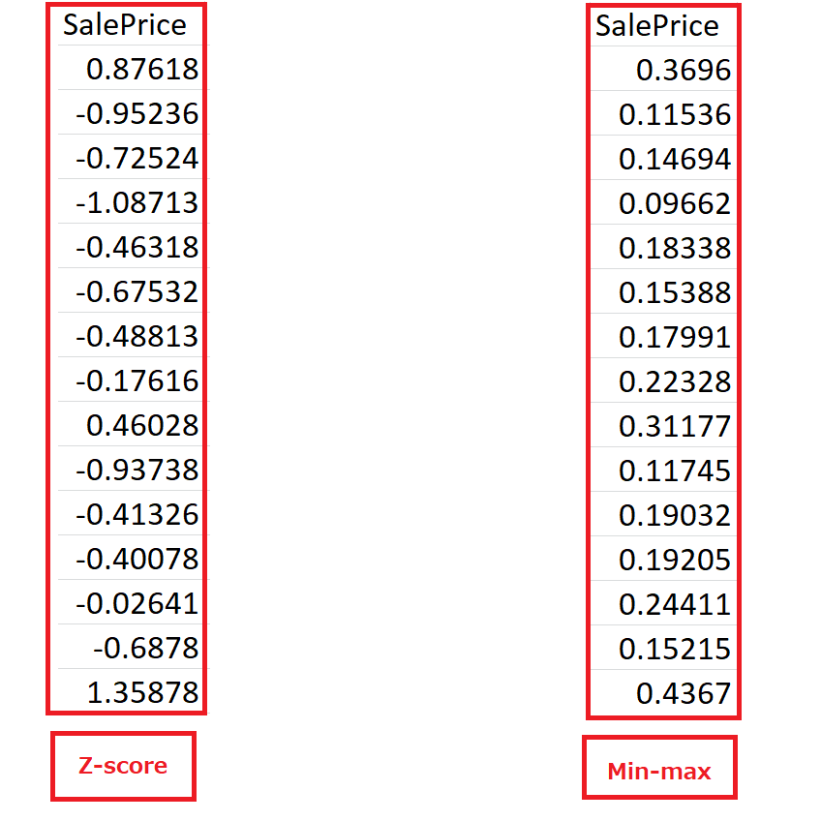

## Add new attribute with given expression

In this example, we pick two attributes which have some missing value: LotFrontage and LotArea and using the expresison “(LotFrontage+LotArea)*3” for testing:

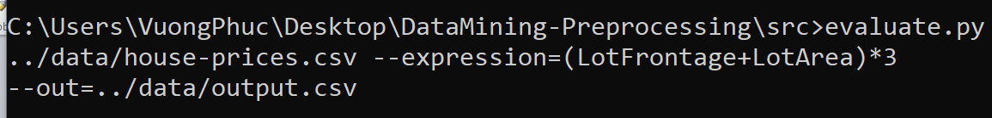

And this is our result:

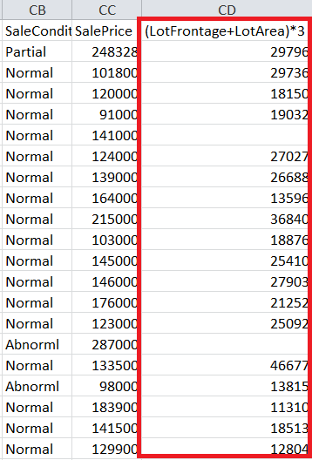

In weka, we can add an expression using AddExpression filter. We can see that LotFrontage is the 4th attribute (a4) and LotArea is the 5th one (a5), so our expression need to fill in is “(a4+a5)*3”

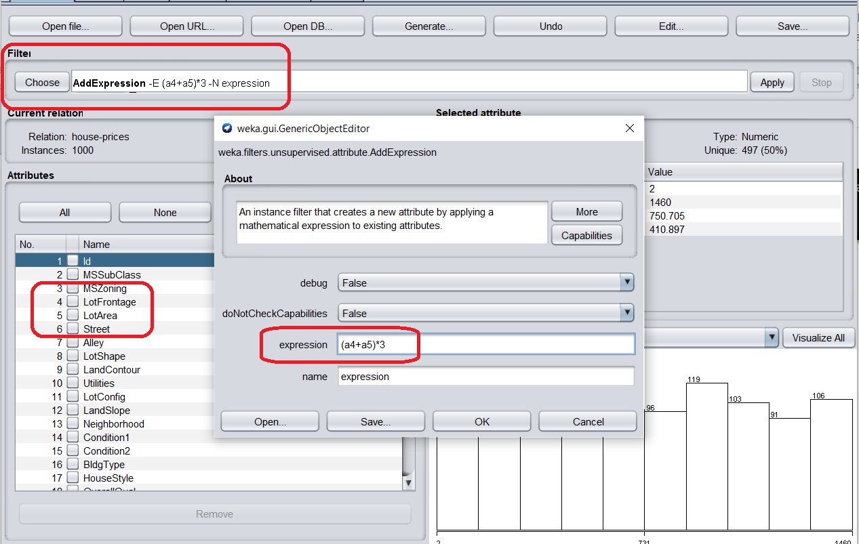

Easily, we can see the result provided by Weka match ours:

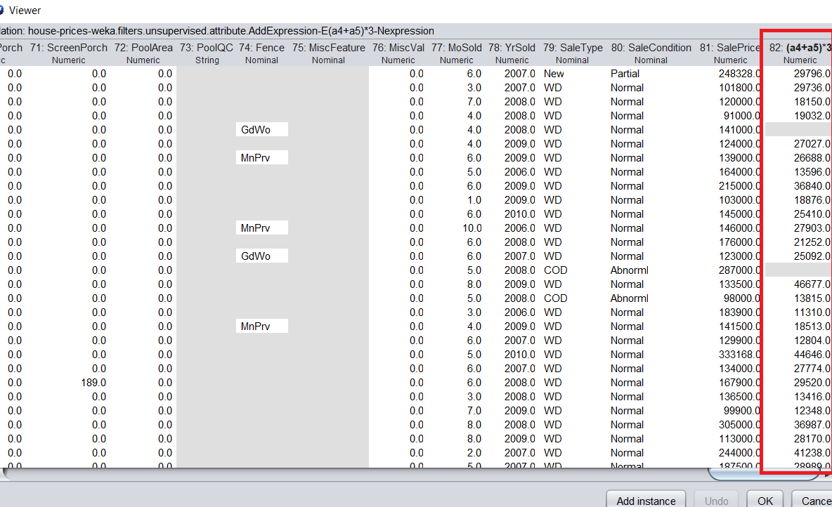

# References

1. Classification Algorithms with Attribute Selection: an evaluation study using WEKA – Dr. S.Gnamambal et al – 04th Apr, 2018
2. Perform feature selection Machine learning data WEKA – Machine Learning Mastery – Jason Brownlee – 13th July, 2018
3. Machine Learning with WEKA WEKA Explorer Tutorial - S. Aksenova - California State University – 2004
4. Quartiles – Math is fun – 2019
5. A Tour of the Weka Machine Learning Workbench – Jason Brownlee – 21st Jun, 2016
6. Attribute-Relation File Format (ARFF) – University of Waikato – 1st Nov, 2008
7. How to Calculate Correlation Between Variables in Python – Machine Learning Mastery – Jason Brown, 27th Apr, 2018